  

**Embedded System**

**Lab 01**

**By :**

**Jaser E Abu Ramadan**

**120200197**

**Submitted to :**

**Eng. Amal Abu jasser.**

**15/11/2024**

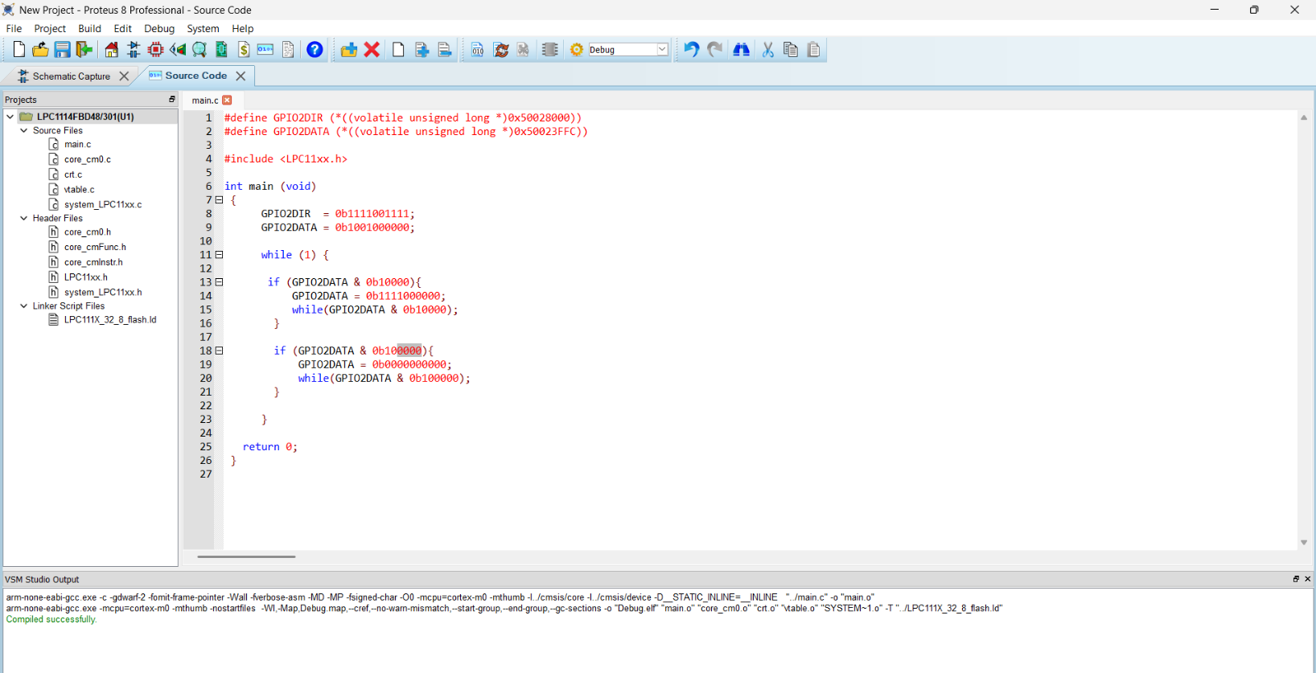

On

OFF

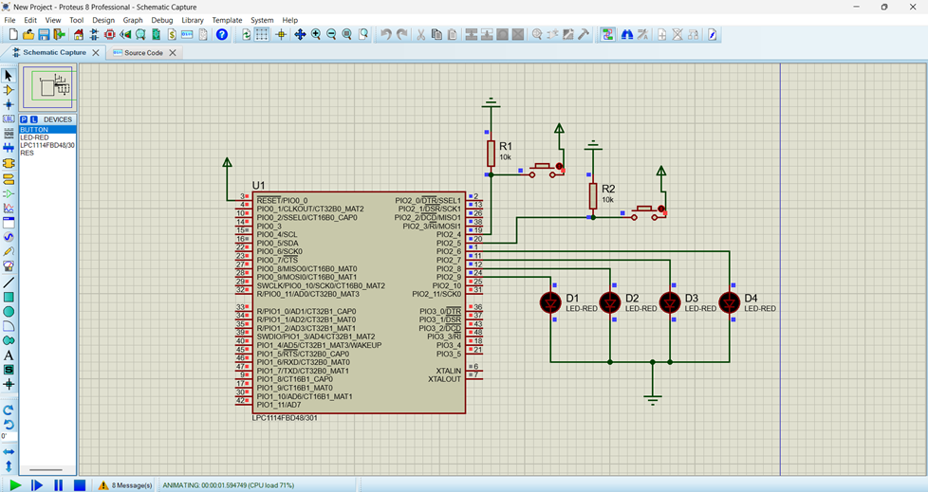

Thank You